- northern trail outfitters uses HTML email.
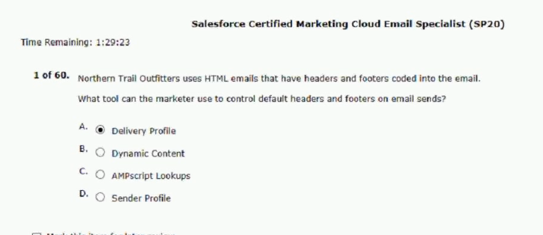
- a marketer created dynamic content for an upcoming campaign
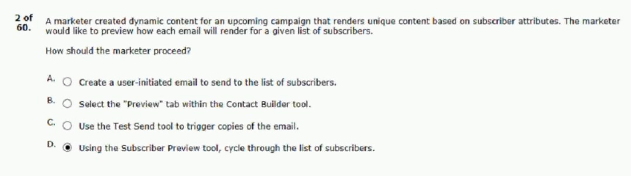
- a marketer at northern trail outfitters must design a targeted
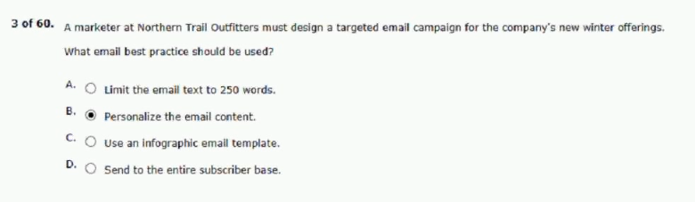

- the northern trail outfitters (NTO) email team is creating a reusable
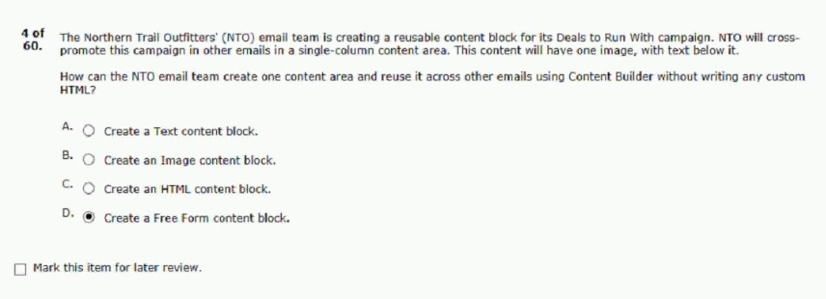
- the marketing team at northern trail outfitters (NTO)
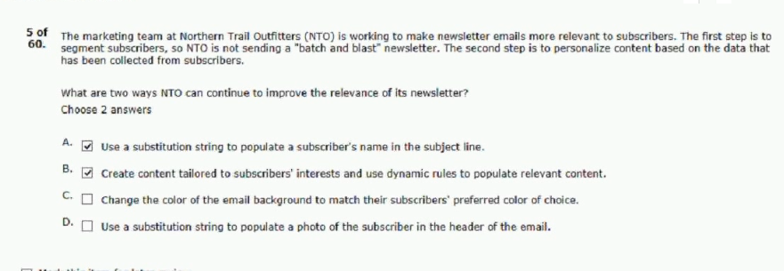
- a marketer wants to send the same email with the same
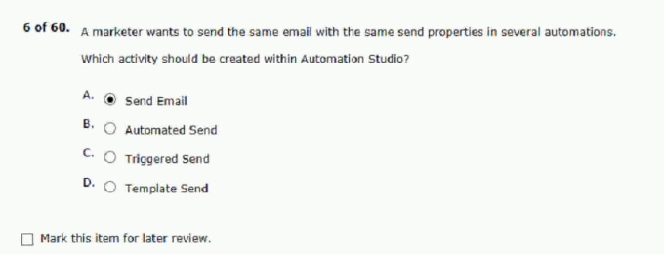

- northern trail outfitters (NTO) has planned cross-channel marketing
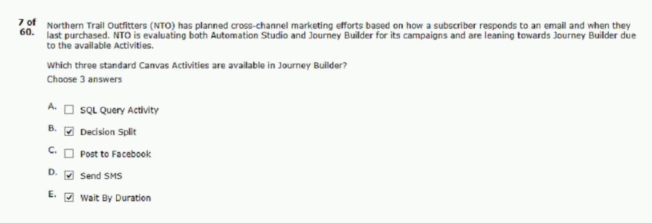
- which two features can be inserted into the code
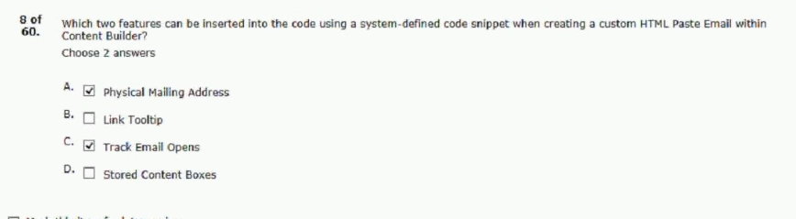
- a customer wants to grow the number
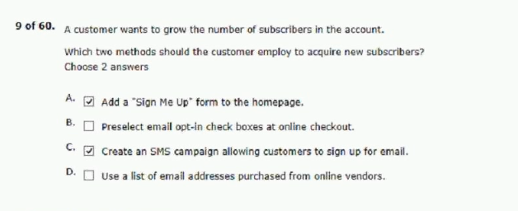

- a marketing team wants to create an automation that can take
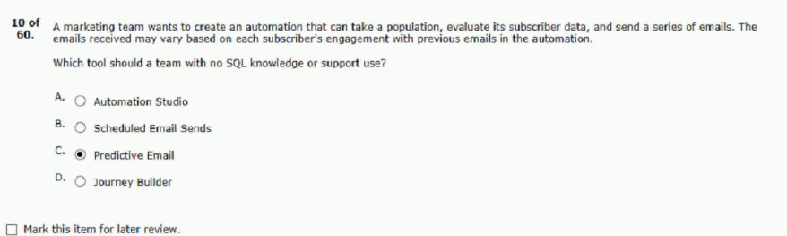
- northern trail outfitters (NTO) needs to use a point-and-click tool
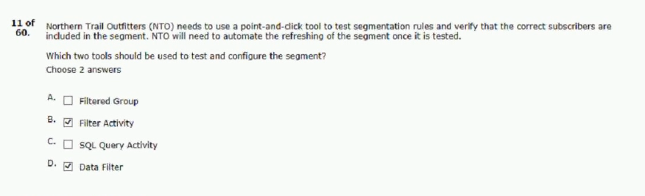
- the marketing manager of northern trail outfitters is interested
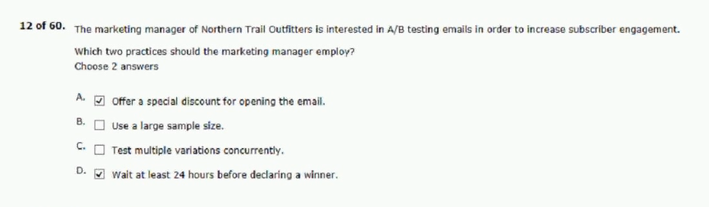

- northern trail outfitters (NTO) wants to ensure a good user experience
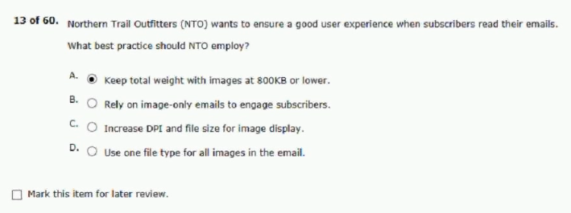
- northern trail outfitters (NTO) has a master subscriber data extension
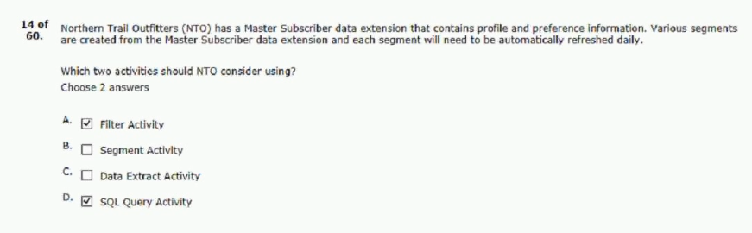
- northern trail outfitters manually sent an html
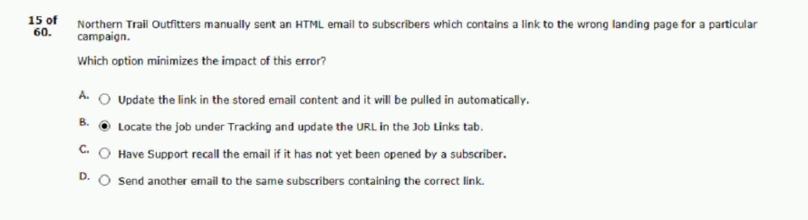

- northern trail outfitters (NTO) has a small catalog of items featured in company emails
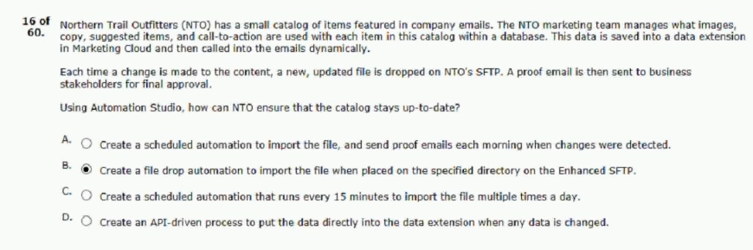
- northern trail outfitters (nto) completed a data review process and discovered
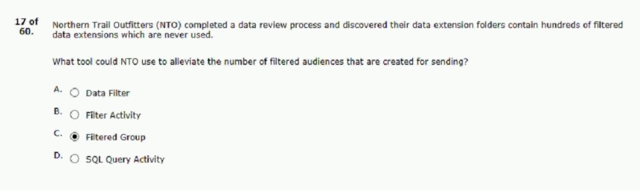
- an email marketing team is setting up a campaign to message
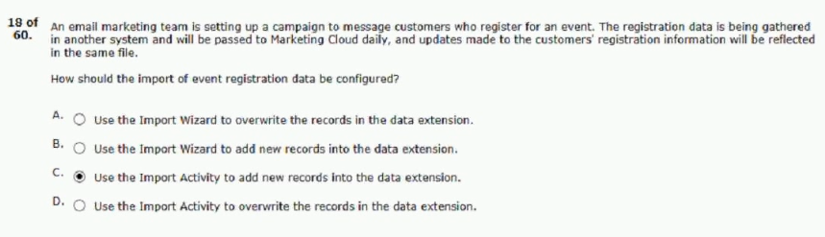

- a marketing team needs to narrow down a customer population
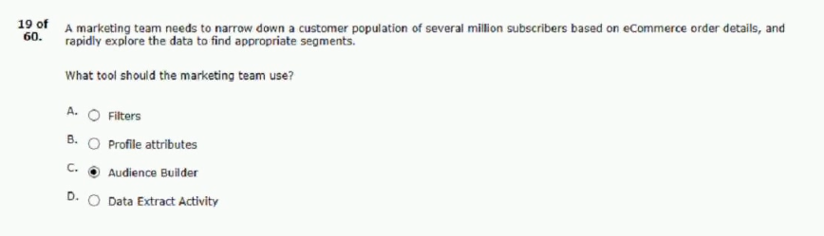
- a local craft store is implementing marketing cloud
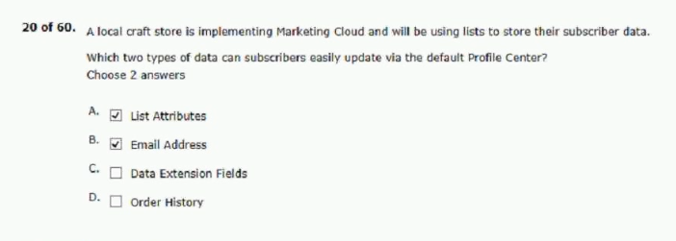
- a new data extension named “orders” contains order data
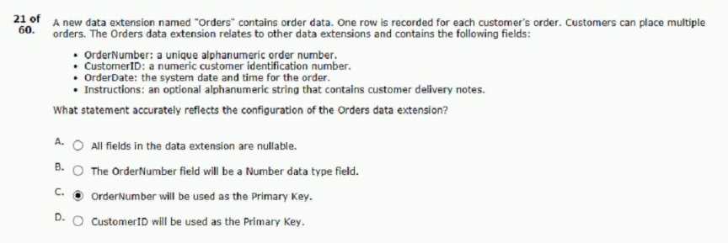

- a customer wants to automate nightly imports and also have the ability
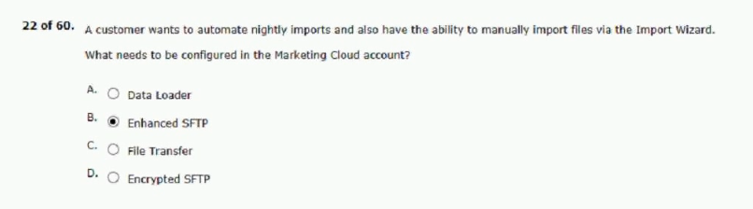
- a marketing team would like to send an email to an audience
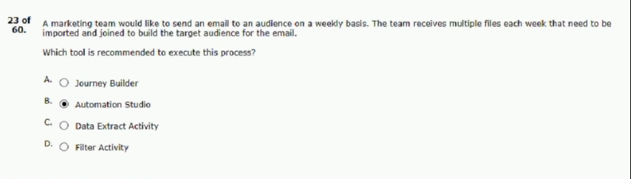
- a marketer would like to improve open rates
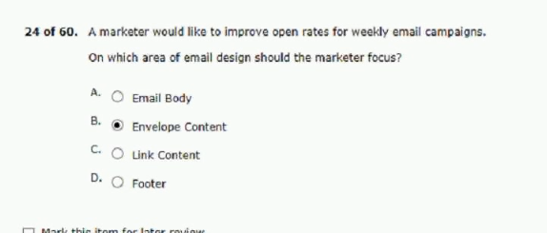

- a national landscaping company wants to send targeted emails
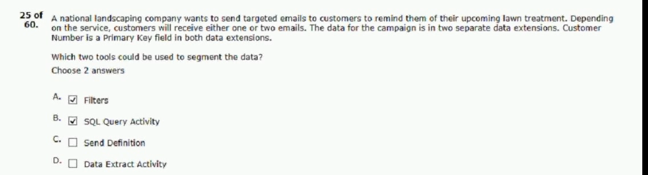
- a marketer plans to send a transactional email
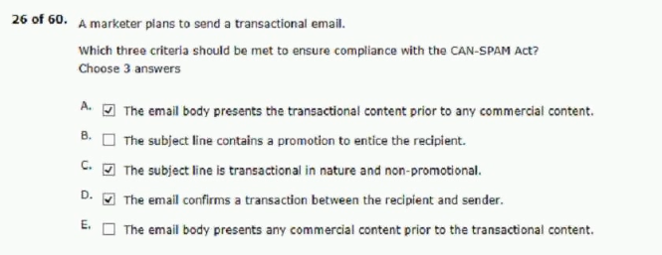
- a data administrator is creating a new data extension
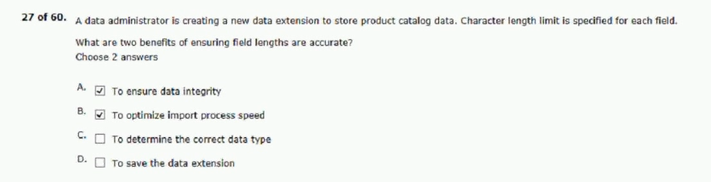

- a digital marketing team noticed an increase in unsubscribes and would
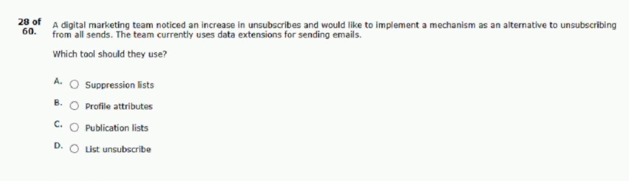
C: publication lists
- northern trail outfitters (nto) plans to launch an email campaign
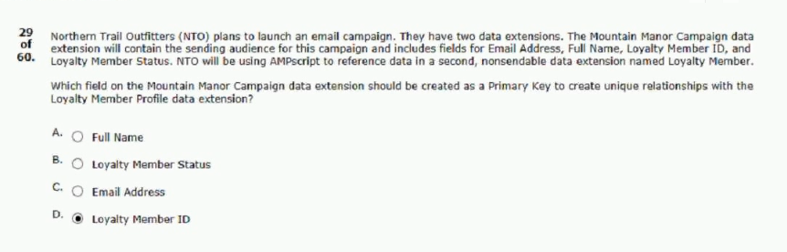
- northern trail outfitters has a list of platinum members containing
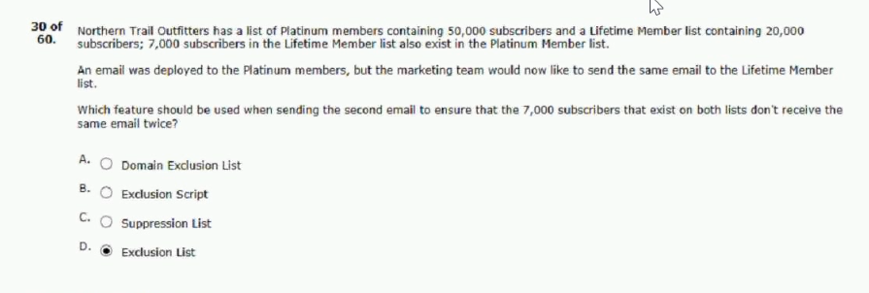

- northern trail outfitters wants to maintain enterprise-wide opt-outs for two segments
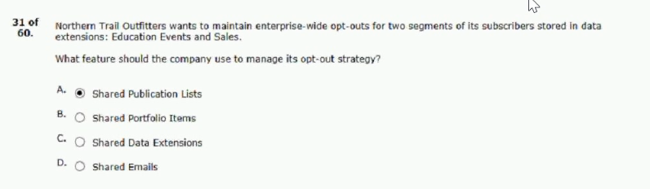
- northern trail outfitters wants to create a welcome series
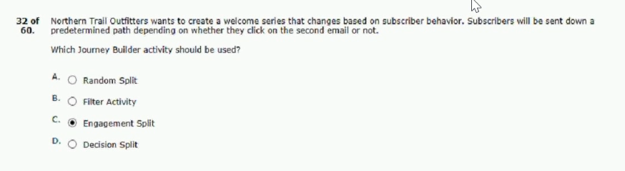
33.northern trail outfitters (nto) is launching a custom, corporate-branded apparel website
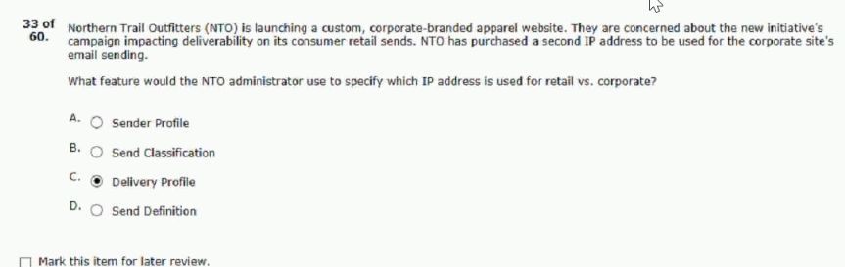

34. a marketer is about to introduce content builder to the entire northern trail
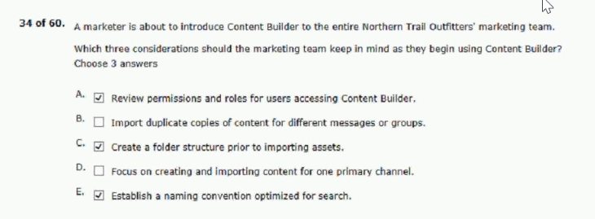
35. northern trail outfitters would like to use a file drop starting source
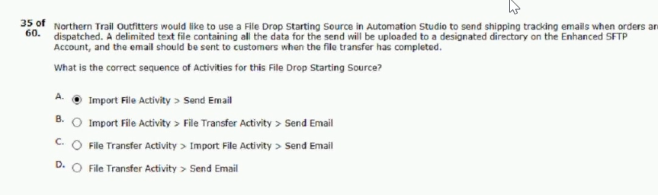
36. northern trail outfitters is looking at using journey builder
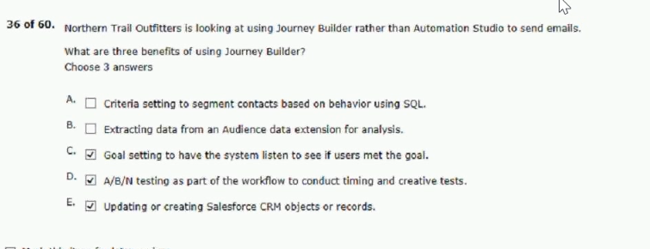

37. the marketing team at a bank needs to receive a file
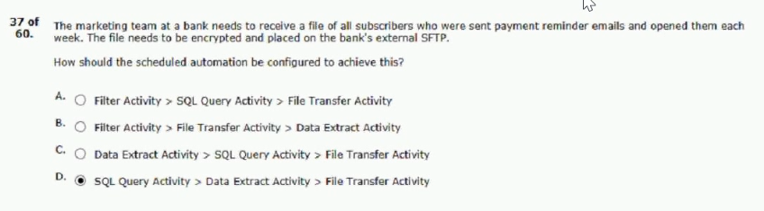
38. a marketer sends an email to a sendable data extension
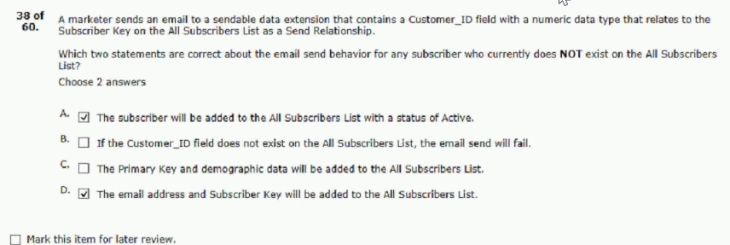
39. a marketer sent an email to a group
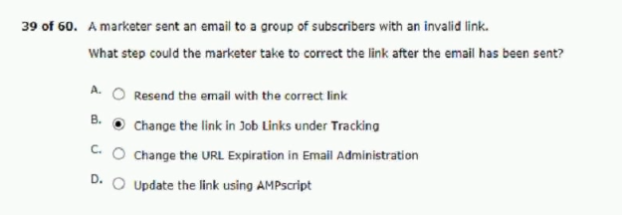

40. a 15-person management team wants to review test emails
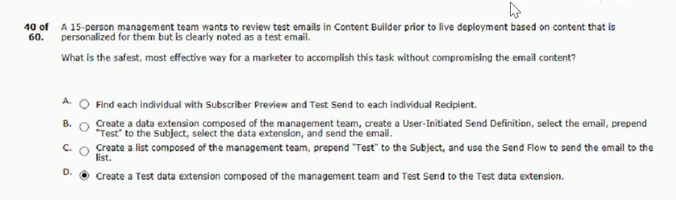
41. northern trail outfitters sent three different emails
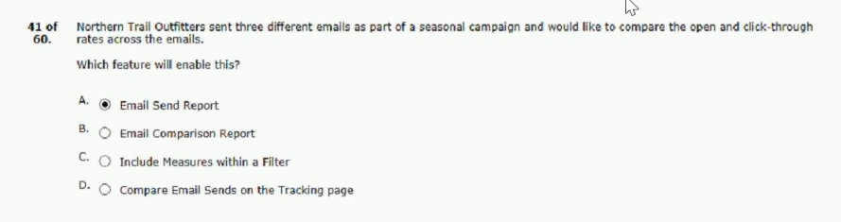
42. a marketer wants to use personalization strings to create
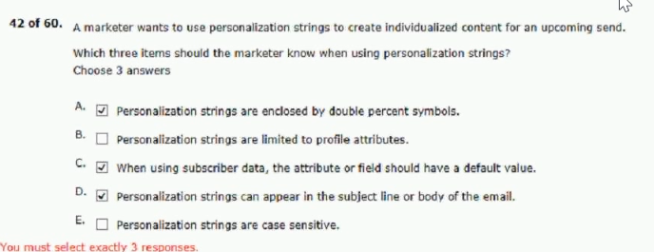

43. northern trail outfitters (nto) is having its annual footwear sale
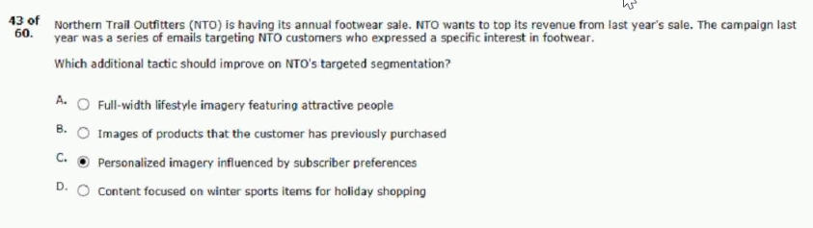
44. northern trail outfitters (nto) wants its emails to render
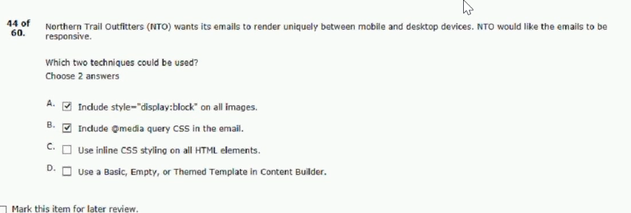
45. northern trail outfitters wants to display different
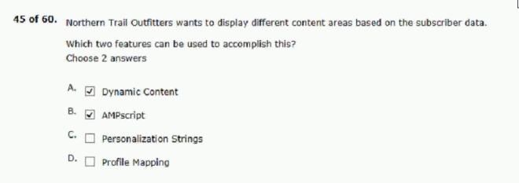

46. a marketer plans to send a commercial email.
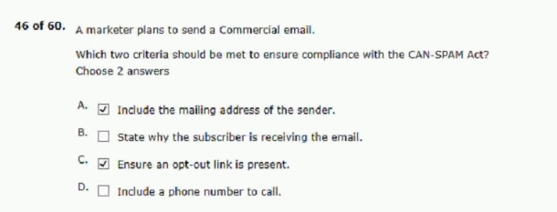
47. northern trail outfitters just launched a new line of tents
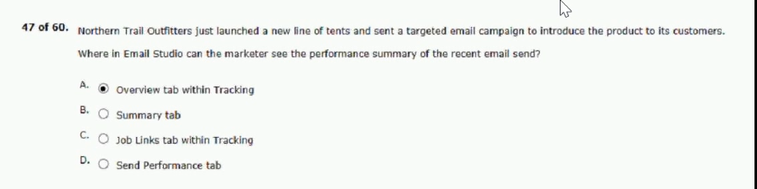
48. a marketing manager would like to run the recent email
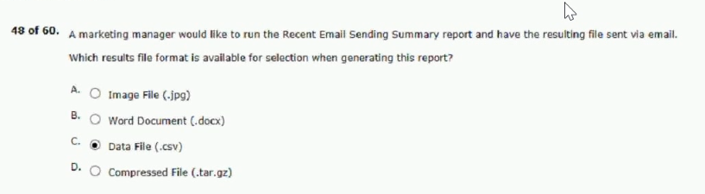

49. a marketing manager wants to provide unique content
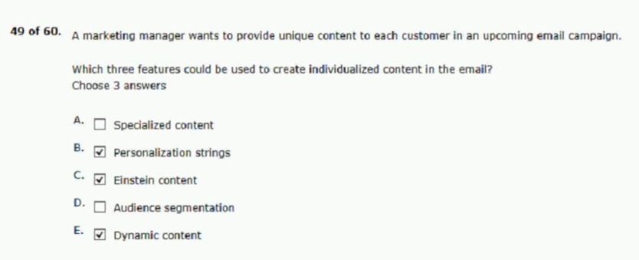
50. northern trail outfitters (nto) is implementing marketing cloud and is unsure
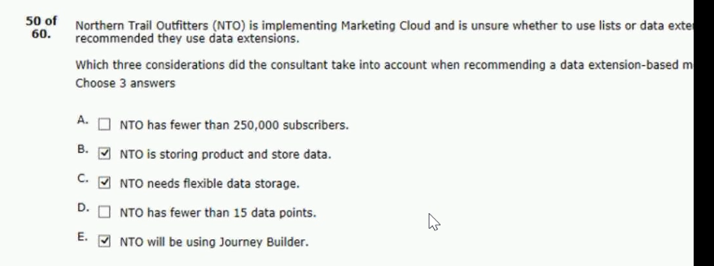
51. a team wants to import a file with column names
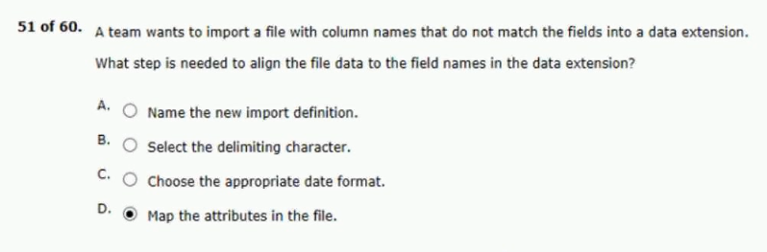

52. northern trail outfitters has a master customer shared data extension
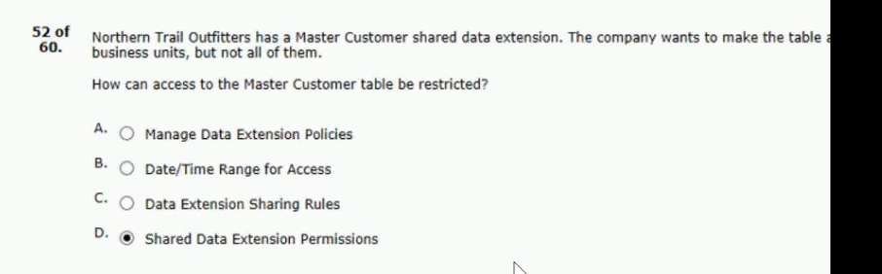
53. a marketer is preparing an email for sending and completing
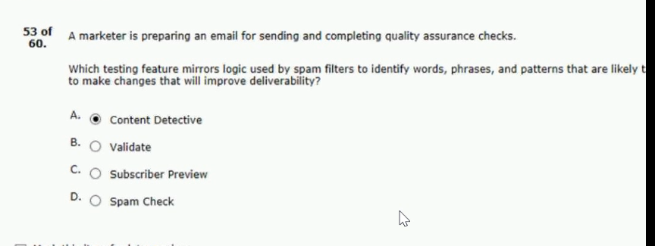
54. a file is received daily from a data provider to the account sftp
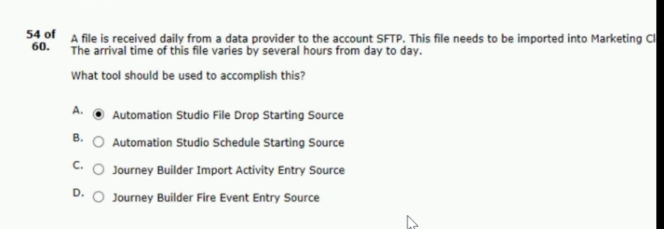

55. northern trail outfitter (nto) launched a new custom preference center to allow customers
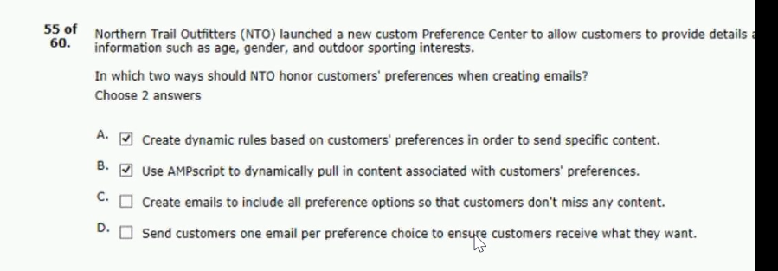
56. northern trail outfitters (nto) marketing team is looking to use a partner
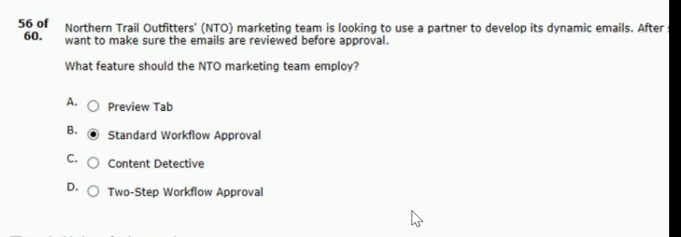
57. a retailer has been gathering email address in-store by asking customers
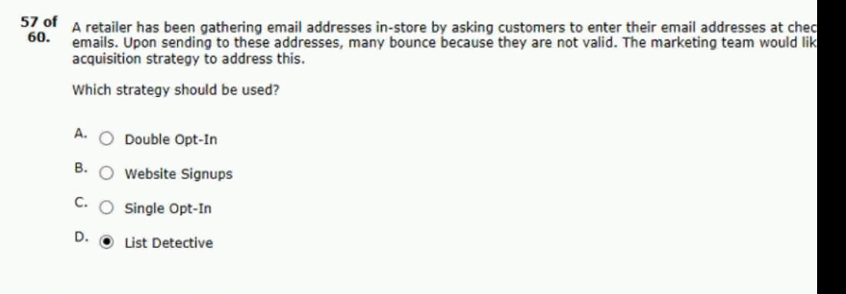

58. northern trail outfitters(nto) branding guidelines require heavy use
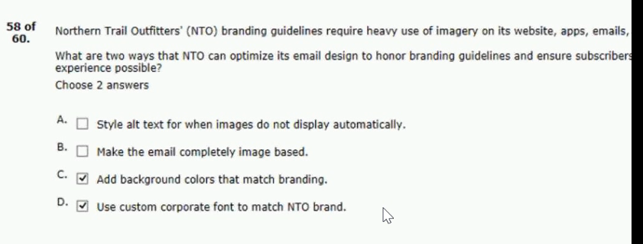
59. the it department at northern trail outfitters would like to receive email
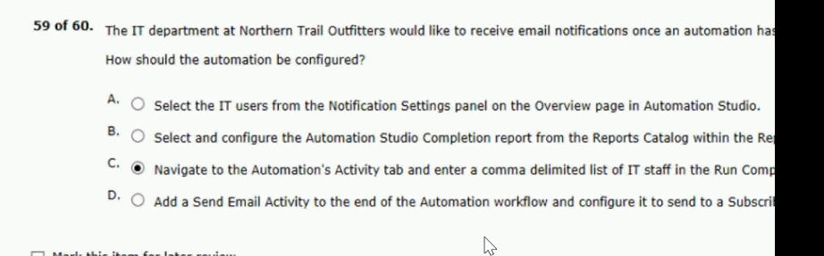
60. northern trail outfitters (nto) would like to improve email open rates
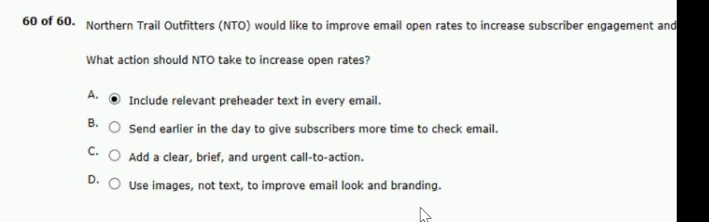

northern trail outfitters (NTO) is launching a monthly newsletter for its subscribers.
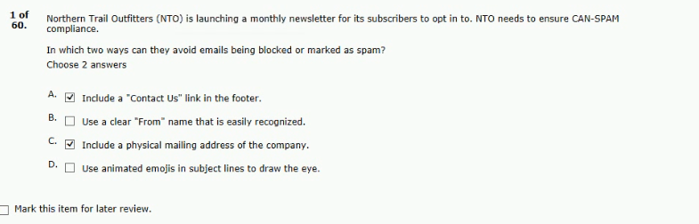
a marketers sends an email to a sendable data extension.
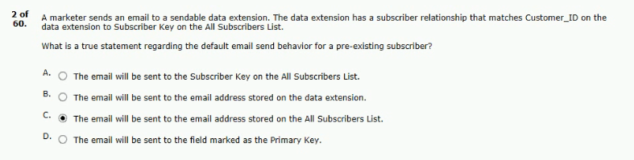
a marketer is conducting a preview and test based on.
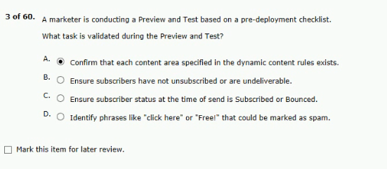

a marketer is updating a data extension by manually importing a file.
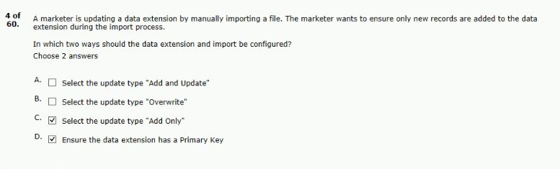
northern trail outfitters (NTO) would like to send shipping email notifications.
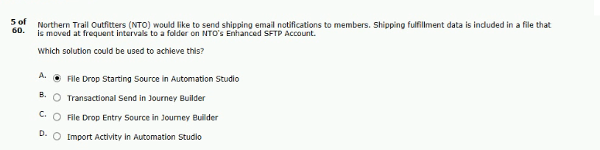
northern trail outfitters sends order confirmations to customers who have made online.
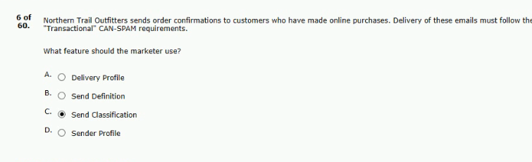

which two best practices should the customer follow to ensure.
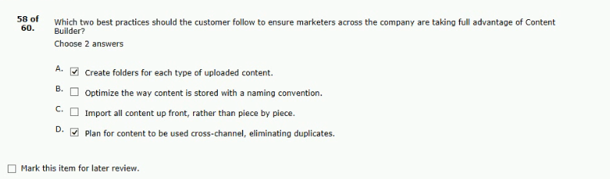
northern trail outfitters (NTO) created several lists of subscribers.
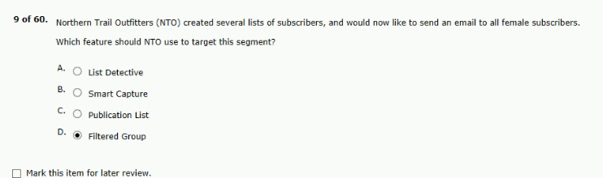
a new marketing manager at northern trail outfitters (NTO) has been asked to evaluate.
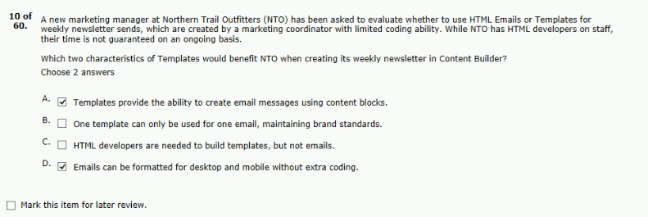

a marketing manager needs to evaluate two creative versions to.
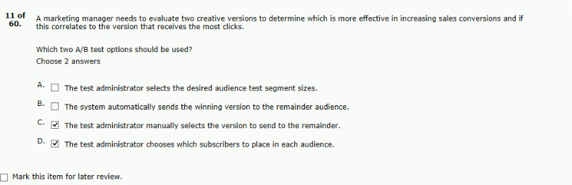
northern trail outfitters (NTO) has been sending email for about 10 yers.
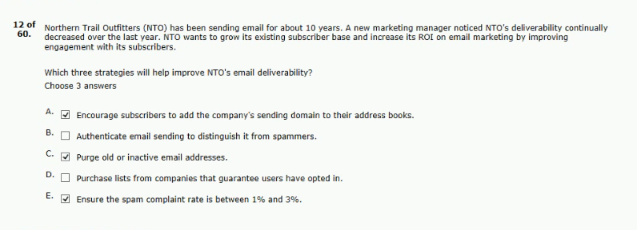
approximately 50% of northern trail outfitters (NTO) subscribers open emails on their.
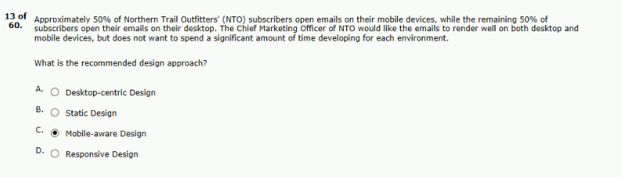

northern trail outfitters (NTO) wants to create a landing page that contains.
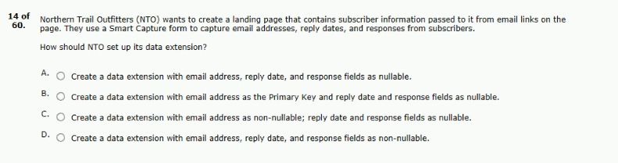
Ans - C
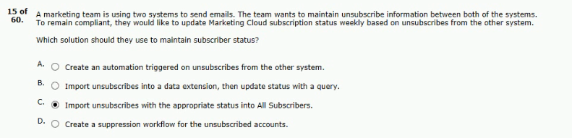
an email marketer needs a point-and-click tool
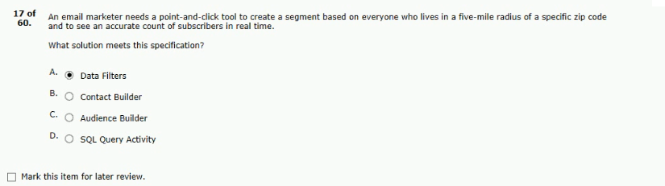
Answer - C
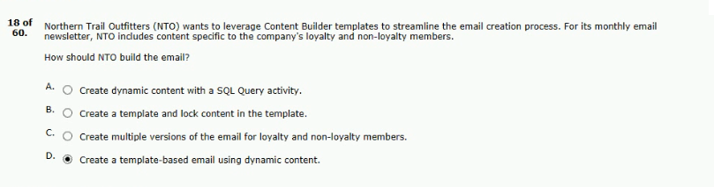
an email marketing team has been tasked with building.
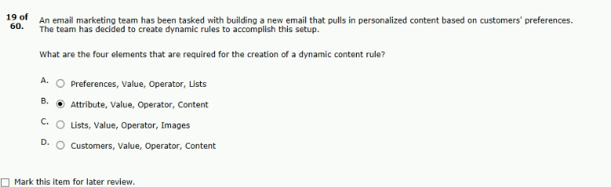
a marketer needs to import a text file and does.
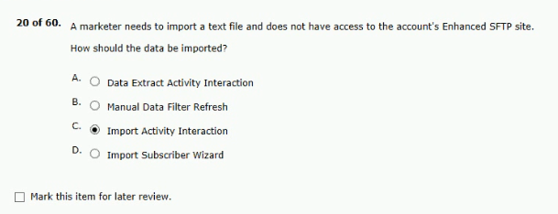
a marketer sent a promotional email to contacts who recently.
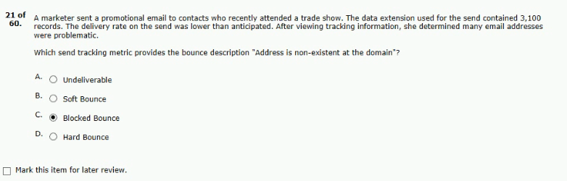

northern trail outfitters is using a smart capture from in cloudpages to .
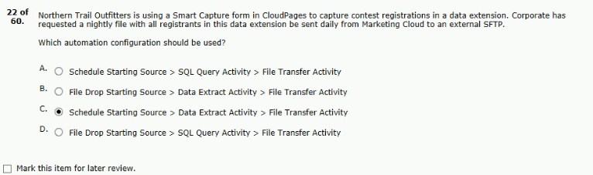
northern trail outfitters wants to use something other than an.
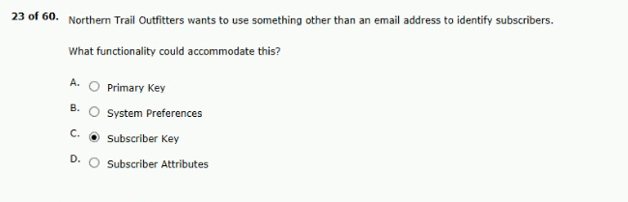
an email marketer has been tasked with increasing open rates.
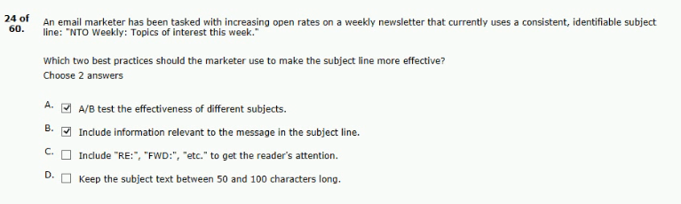

northern trail outfitters’ marketing team includes the nearest store to.
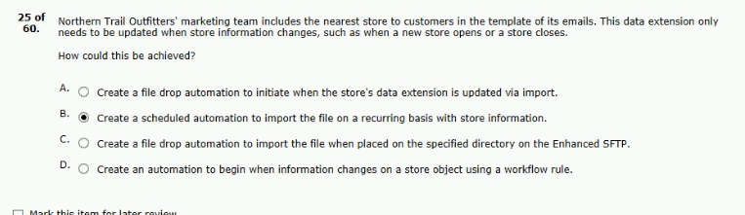
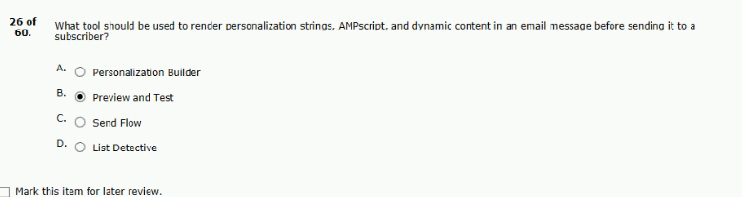
a subscriber unsubscribers upon receiving an email northern trail outfitters (NTO).
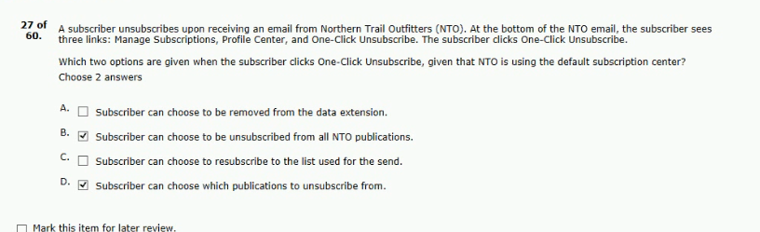

northern trail outfitters (NTO) just hired a new associate who is brand.
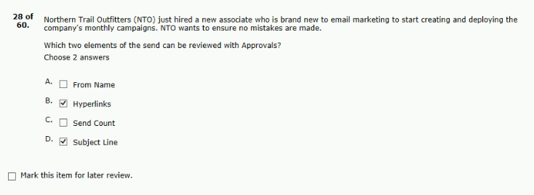
a marketer is using list-based sending and wants to segment.
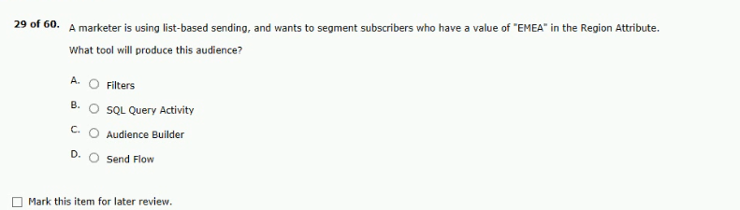
Ans - A
a company has one million subscribers. the company has a master data.
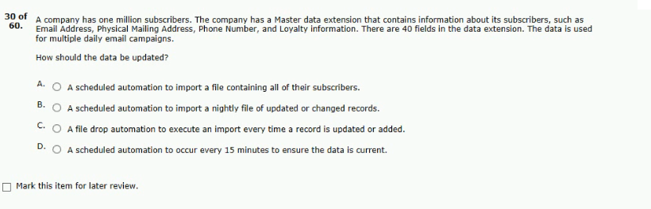
Ans - C
a national public university distributed a newsletter to alumni,student.
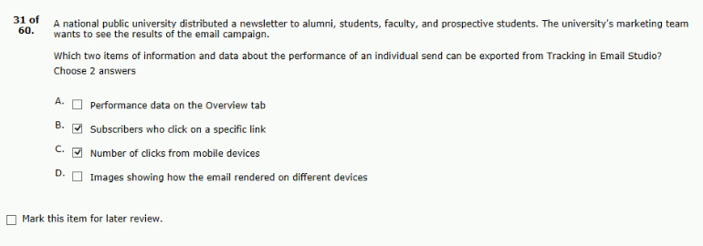
northern trail outfitters (NTO) wants to ensure its emails are meeting.
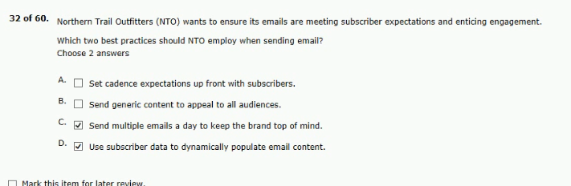
while testing an email with dynamic content in content builder.
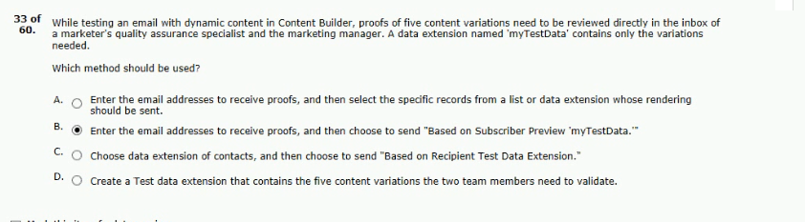

a customer leverages transactional messages to
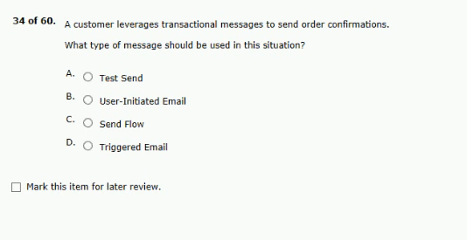
Ans - D
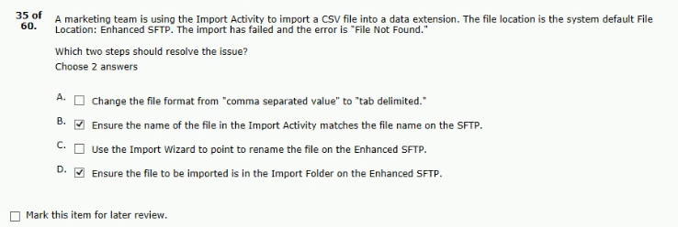
a company has set out to increase their subscribe base.
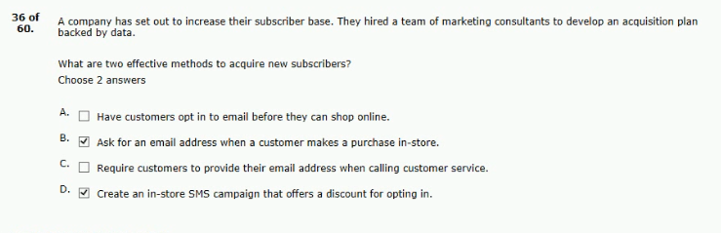

northern trail outfitters (NTO) offers a 90-day trial on weekly snack.
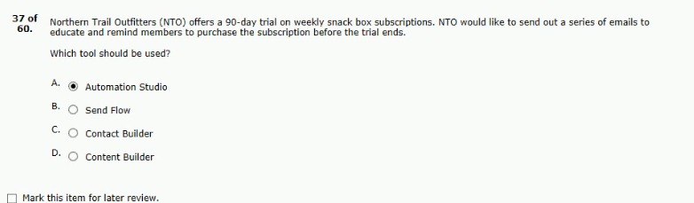
northern trail outfitters (NTO) would like to target members who recently.
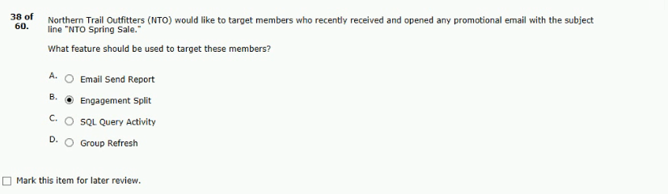
a marketer for northern trail outfitters (NTO) needs to dynamically.
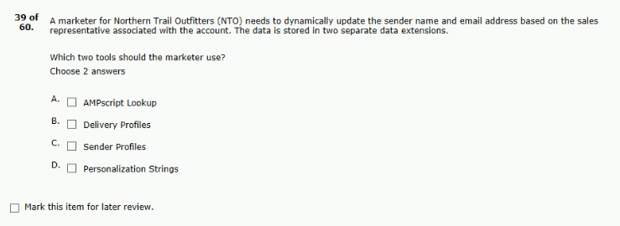
Ans - AC

which two subscriber audience can be created by.
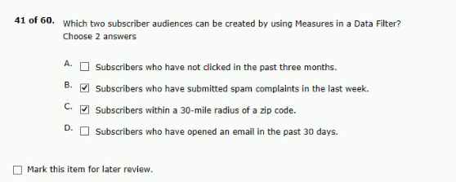
northern trail outfitters has hired a new emil designer who.
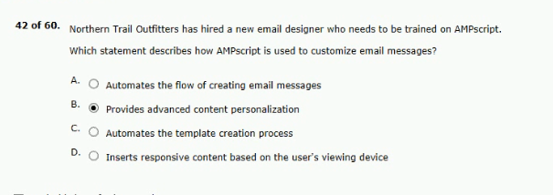
each time northern trail outfitters sends its monthly promotional email.
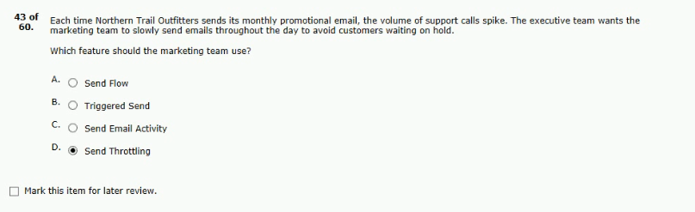

a marketer is designing email for mobile devices.
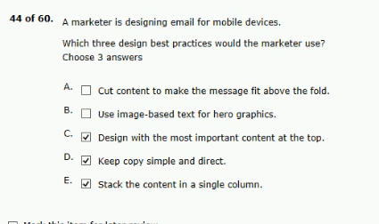
a small company,with limited resources, has started to use.
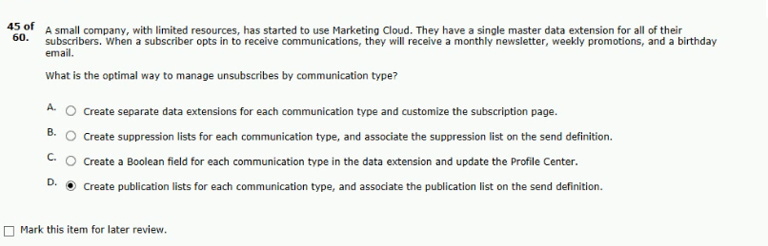
northern trail outfitters (NTO) is currently out a single.
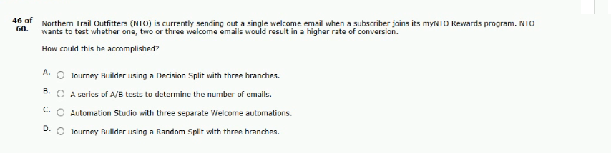
Ans - A

a marketer is building a highly personalized email which is sent.
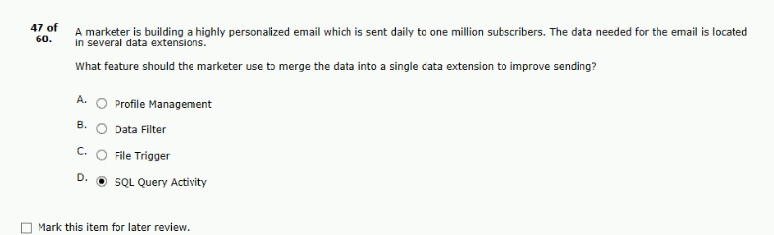
a marketing team is creating a new data extension. the data extension configuration.
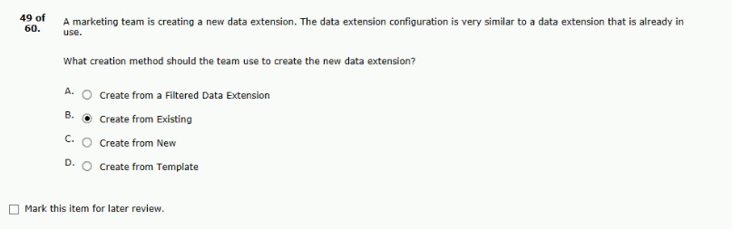
northern trail outfitters (NTO) users link aliases within the HTML versions.
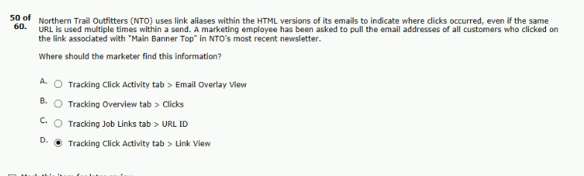

as part of a daily shipping notification automation, northern trail outfitters.
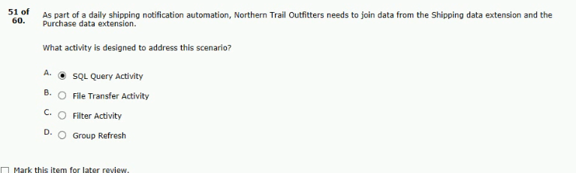
an account will be providing a unique key for each subscriber.
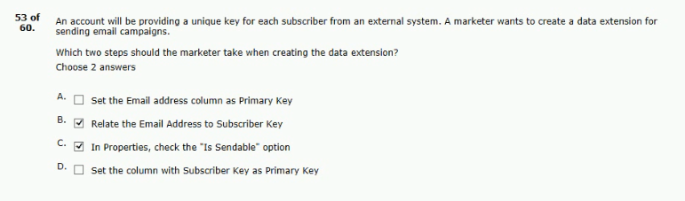
a marketer needs to share report results with a manager.
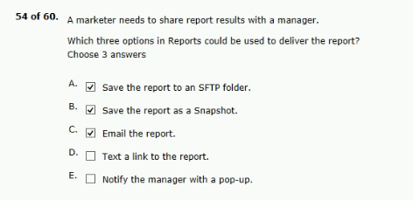

a customer has a send log they are using to track the email.
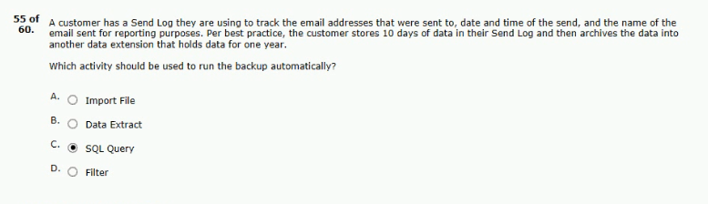
northern trail outfitters (NTO) plans to evaluate with email content customers.
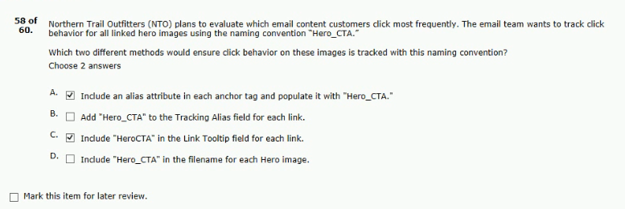
a marketer has been tasked with ensuring northern trail outfitters.
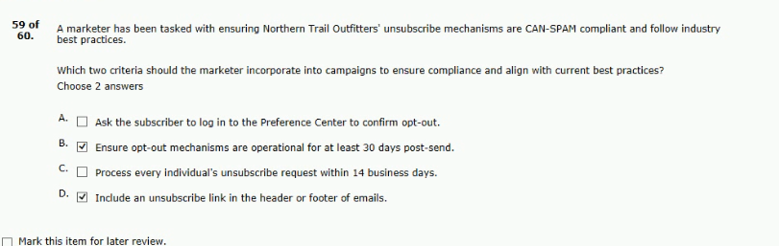

northern trail outfitters (NTO) has created a new onboarding series for customers.
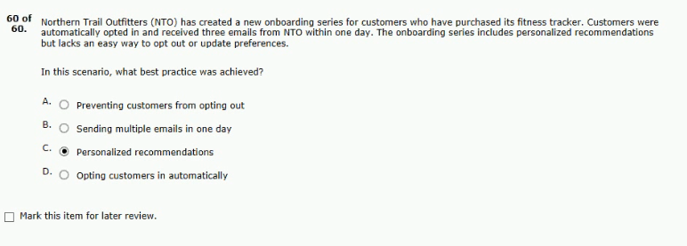
61. northern trail outfitters (nto) is currently sending out a single welcome email
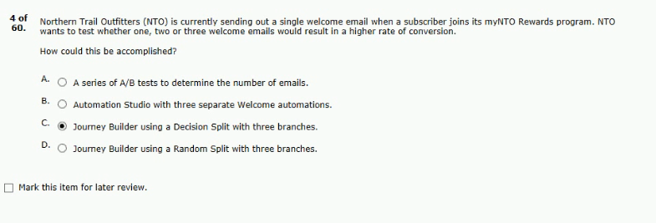
62. what tool should be used to render personalization strings
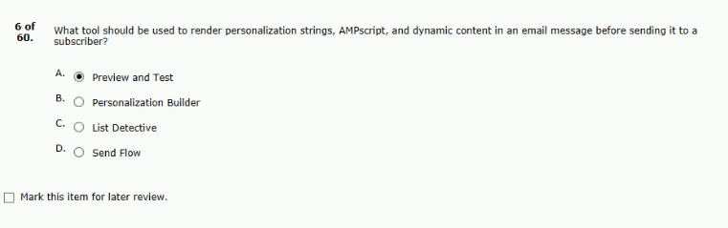

63. a marketing team is using two systems to send emails
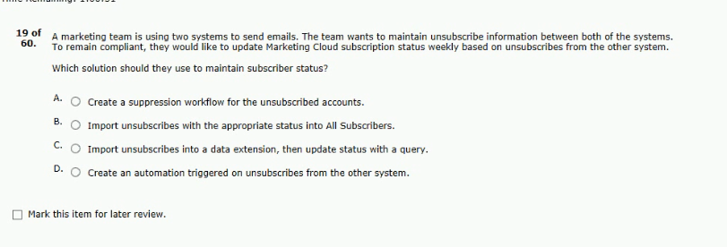
Ans - B
64. a marketing team is using the import activity to import a csv file into a data extension
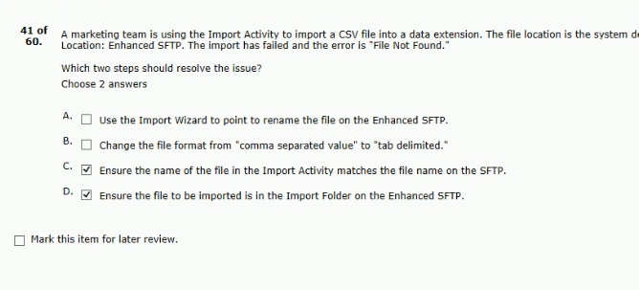

65. a marketer at northern trail outfitters (nto) has been tasked with growing its email
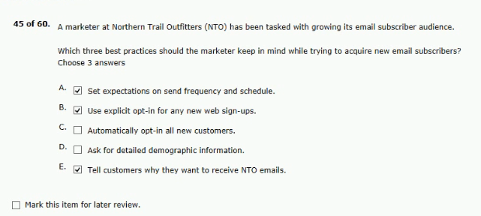
66. northern trail outfitters (nto) uses link aliases within the html versions
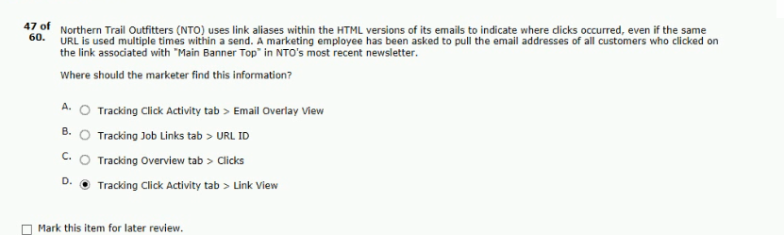
67. northern trail outfitters (nto) wants to leverage content builder templates to streamline the email creation process
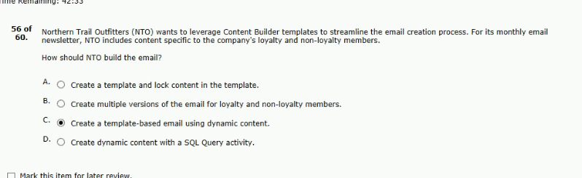

68.northern trail outfitters wants to test five different welcome.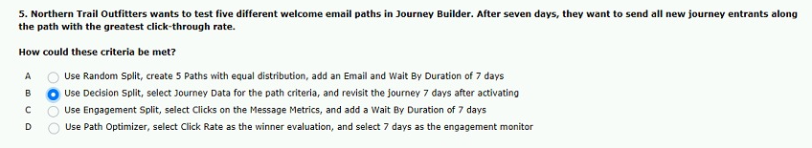
69..northern trail outfitters wants to create a segment that will.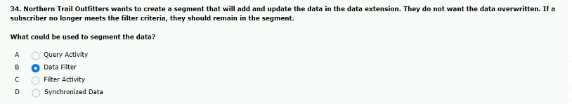
70..northern trail outfitters wants to send monthly birthday.
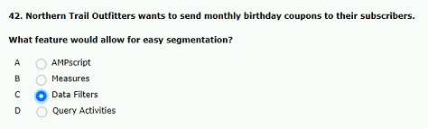
71.a customer is planning to redesign the company website and email.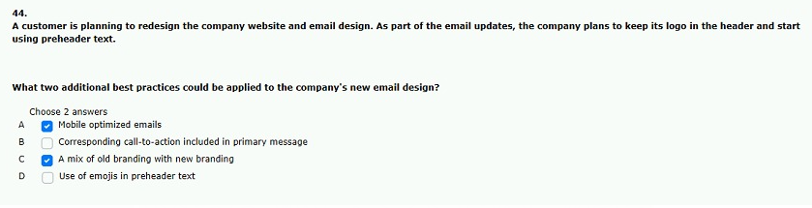
72.a marketer at .northern trail outfitters feels a subject line suggested.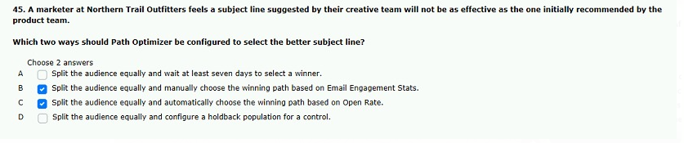
73..northern trail outfitters wants to send promotional offer every friday.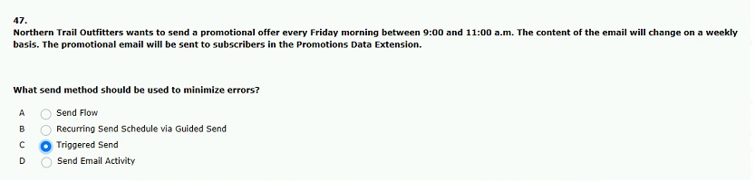
74..northern trail outfitters wants to increase email.
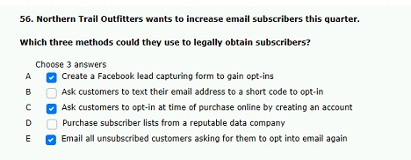
75..northern trail outfitters wants to ensure their emails are meeting subscriber.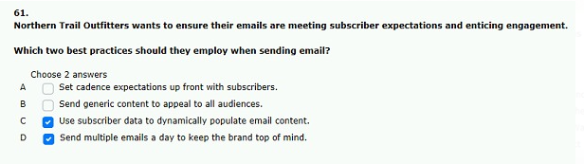
76.northern trail outfitters wants to make newsletter emails more.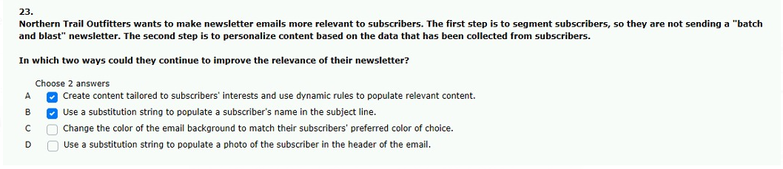
77.northern trail outfitters is implementing marketing cloud and is unsue.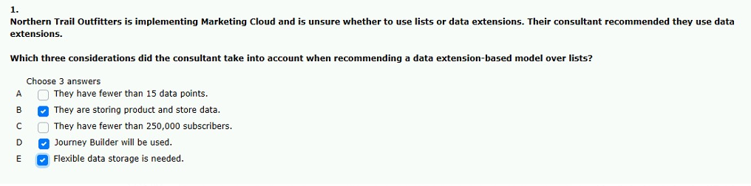
78.northern trail outfitters stores all customers information in a data.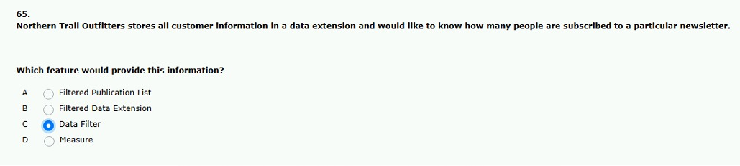
79.a marketer at northern trail outfitters feels a .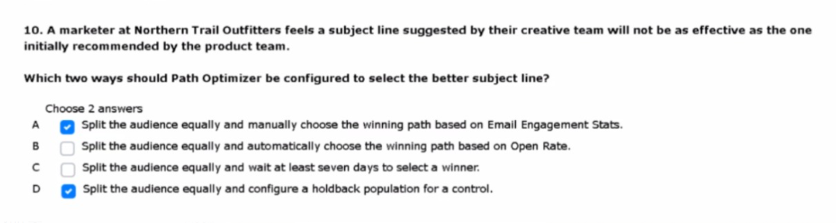
80.northern trail outfitter wants to use a partner to develop dynamic.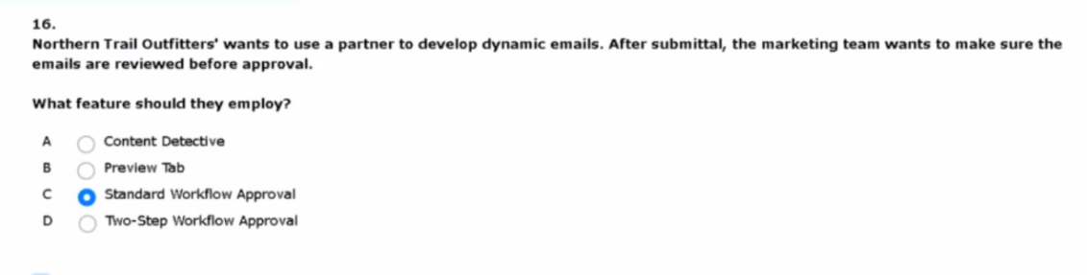

81.a marketer wants to improve open rates for.
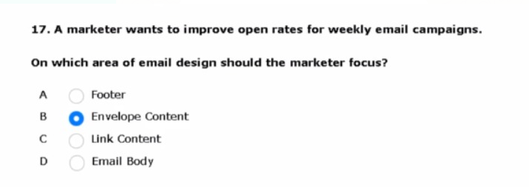
82.northern trail outfitter wants their emails to render.
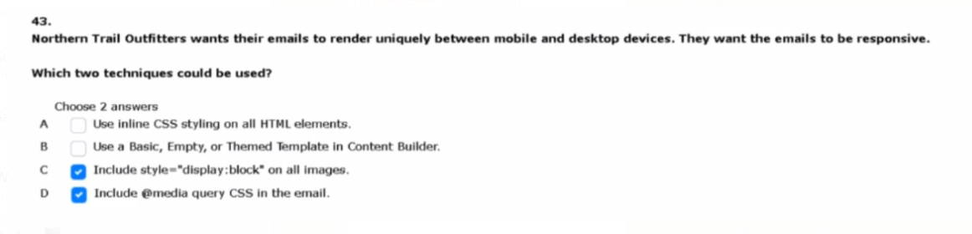
83. northern trail outfitters wants to improve email open rates to increase subscriber
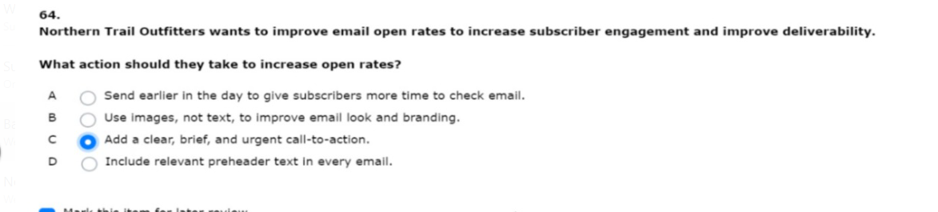
84. northern trail outfitters’ marketing team has added a new business unit
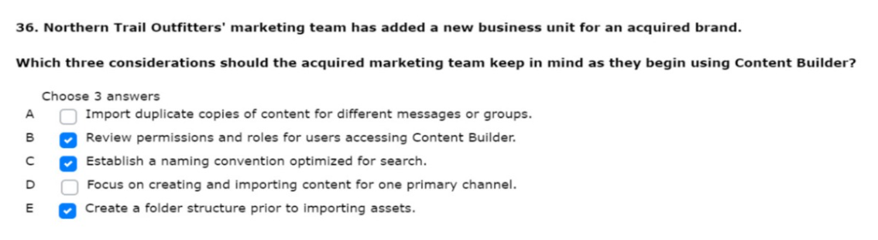
compared to their typical sends
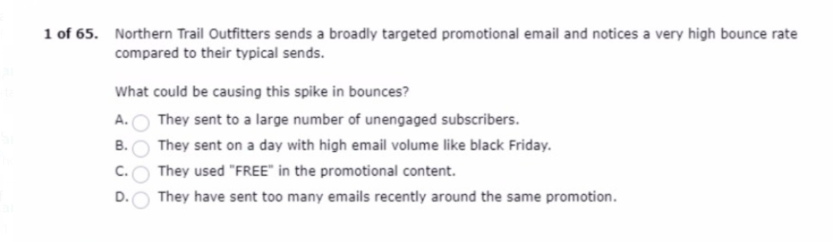
D- they have sent too many emails recently around the same promotion
build the target audience for the email
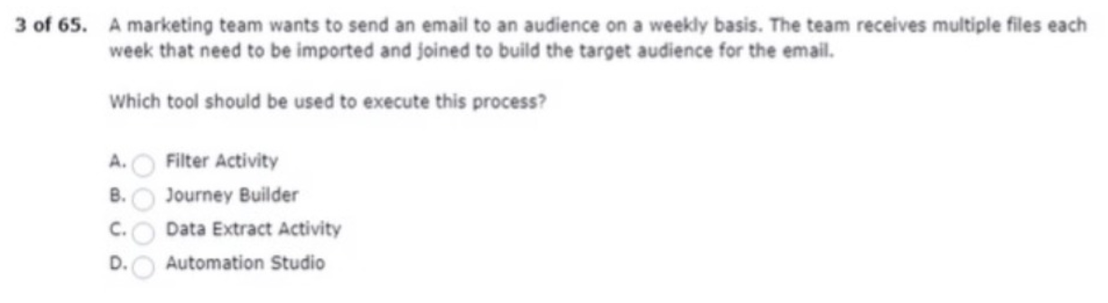
journey builder

they want to ensure no mistakes are made
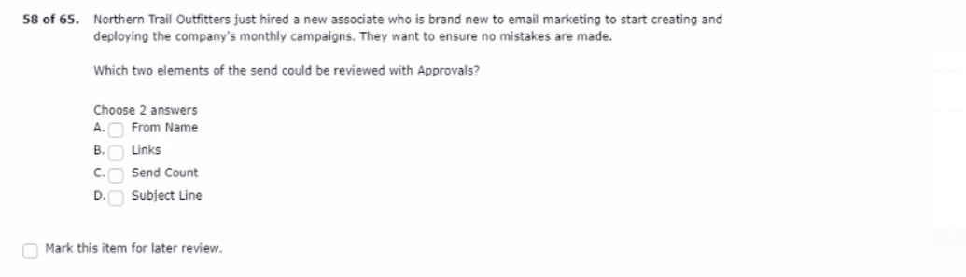
from name
subject line
as outlined by the can-spam act
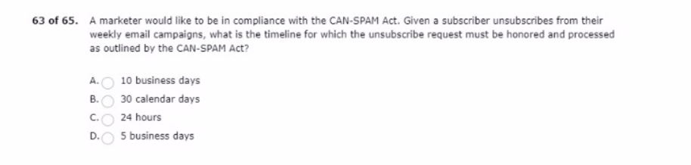
30 calendar days,
the current date in order emails
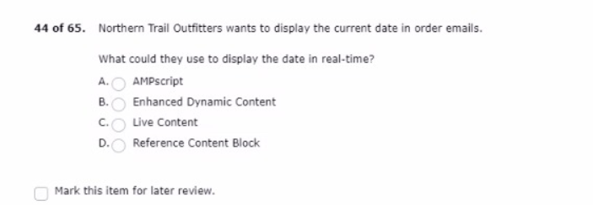
AMPScript

and email address is a required field
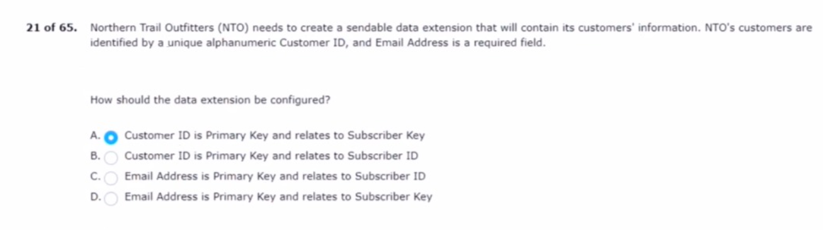
wants to optimize email engagement
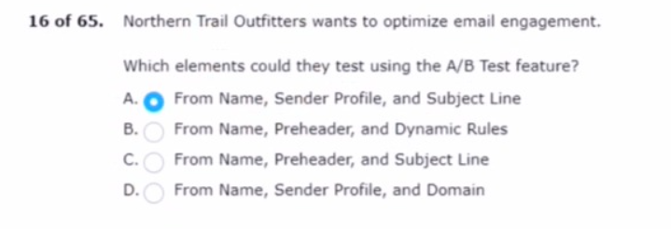

a very high bounce rate compared to their typical sends
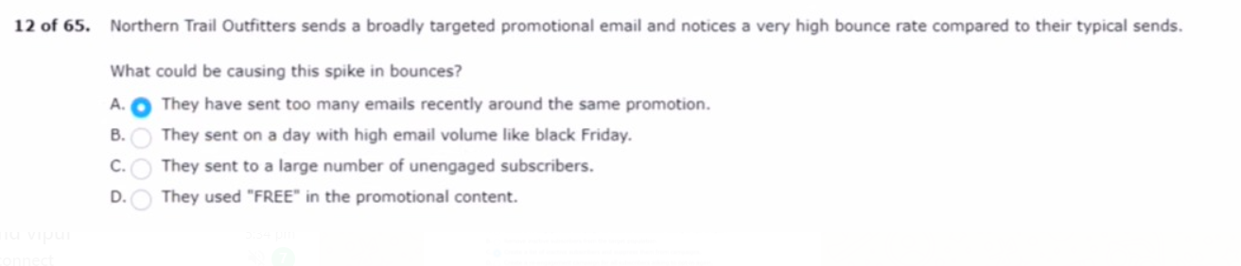

that was missed by the approver
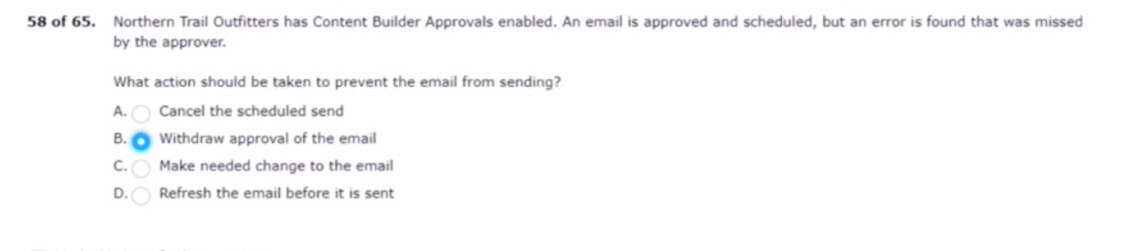

send summary report
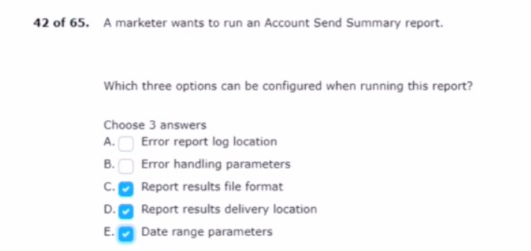

the default content
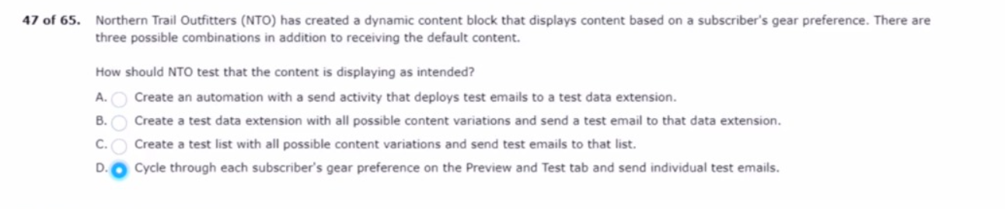

a marketer at northern..their email subscriber audience.
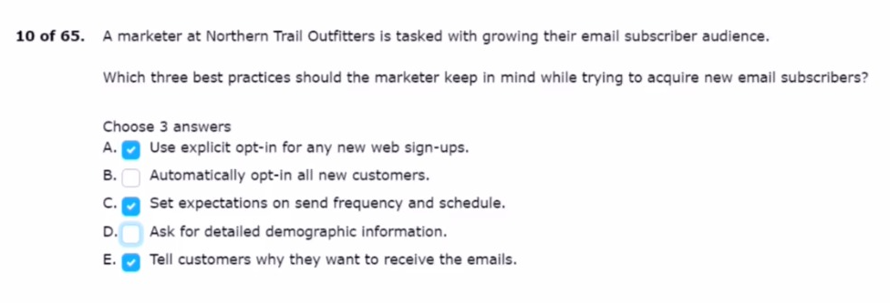
the chief marketing officer at..increase engagement of existing subscribers.
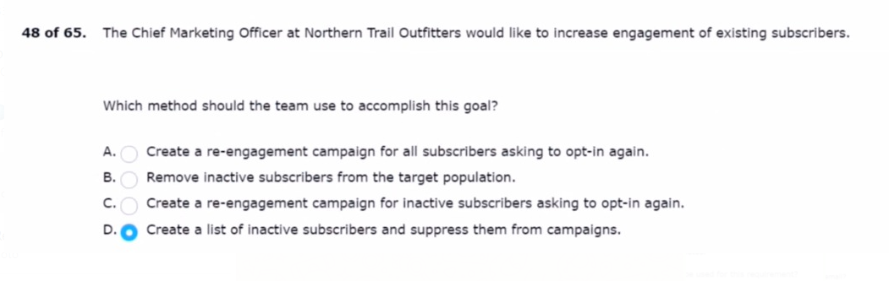
northern trail outfitters (nto) has a strict policy that………….emails featuring professional athetes.
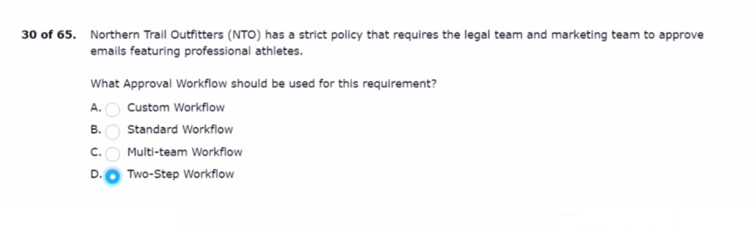

a subscriber received a purchase confirmation email……...contain a way to opt out.
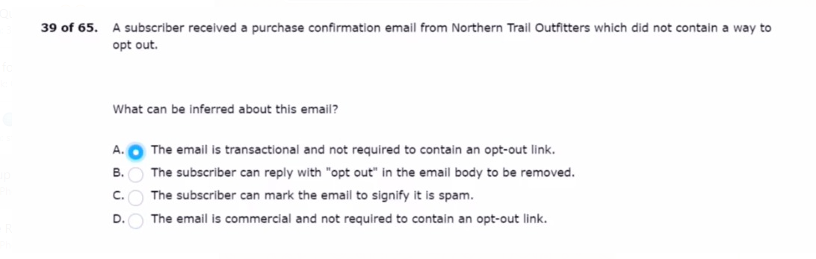
in an effort to improve open rates…..to have an engaging from name.
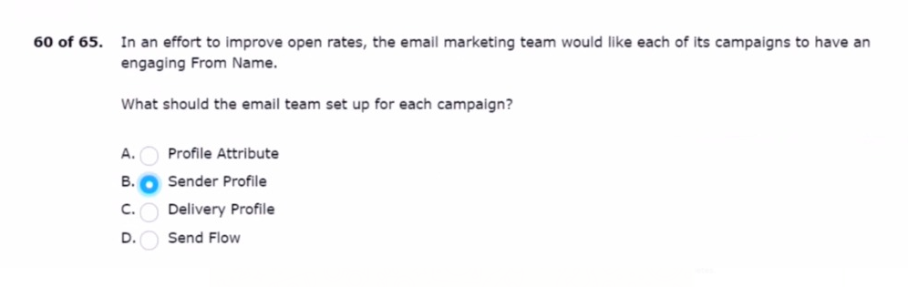
a marketer wants to create a responsive ...across all email clients.
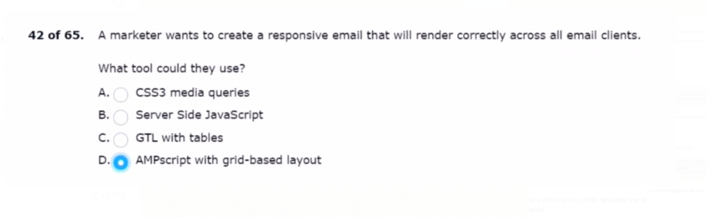

northern trail outfitters (nto) sends a hiking newsletter to an...nto wants to reverse this trend.
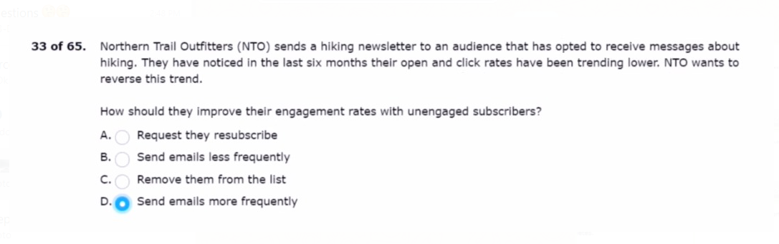
a leading b2c fuel producer and supplier...its email marketing program.
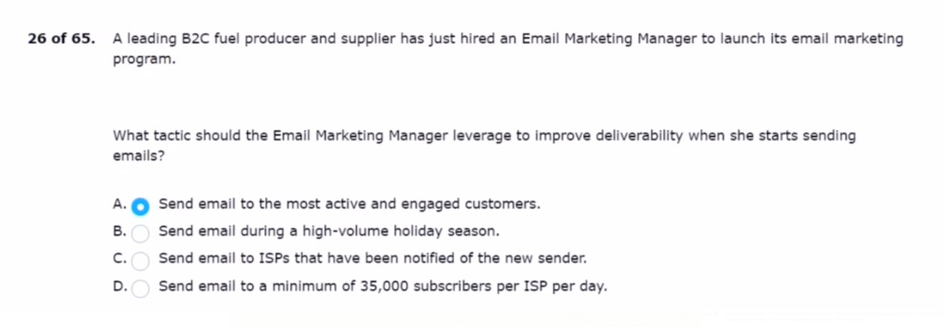
a marketing team has done an audit…..receives data delimited by
after into marketing cloud?
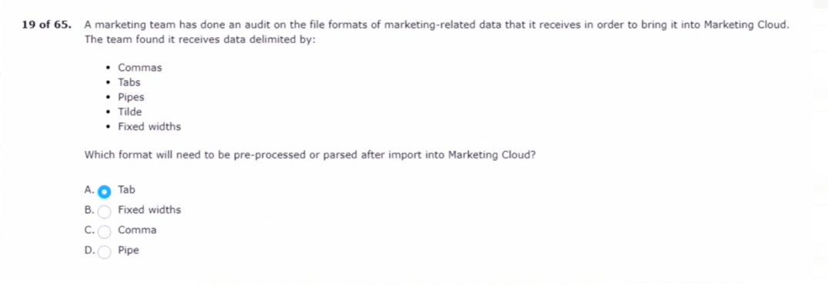

a marketer is configuring path optimizer….but the option os unavailable.
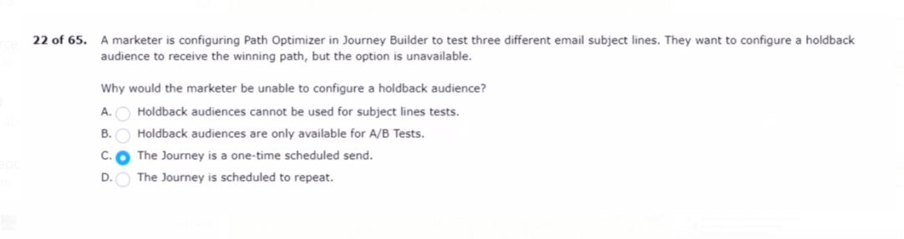
a marketing manager is looking at the tracking...excited about having a 100% open rate.
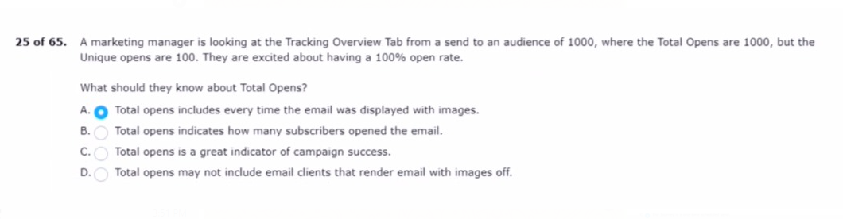
Northern trail outfitters wants to use a point-and-click tool to test.
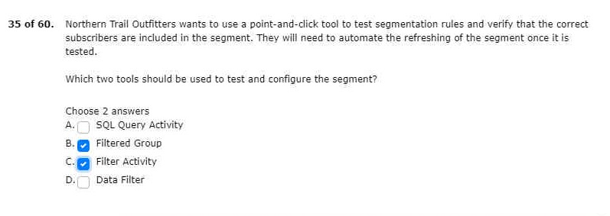

northern trail outfitters wants to use a file drop starting source
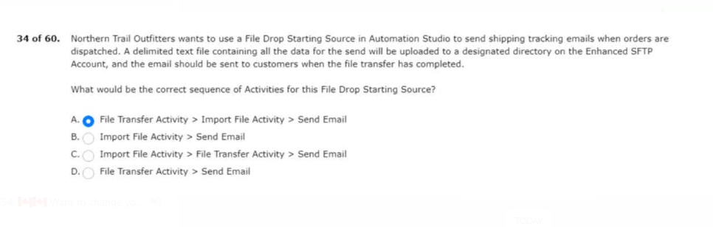

northern trail outfitters wants to send shipping email notifications to members.
